Government of Maharashtra
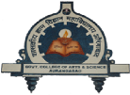
Government College of Arts & Science, Aurangabad (M.S)
(Established in 1923)
(Kile Ark, Near Subhedari Guest House, Aurangabad)
Email ID: gasca1923@gmail.com | Phone/Fax: 0240-2331476 | Website: www.gasca.ac.in

INSTITUTIONAL BEST PRACTICES
Practice No.2
1. Title of the practice: Intensive training for Holistic Development
2. Objectives of the practice
- To develop students with holistic approach
- To develop students intellectually, emotionally, physically and spiritually
- To achieve overall wellbeing of students
3.The Context
Government college is the first higher educational institution in Marathwada region. Most of the students are from agrarian family. Their schooling is from rural area. These students need inclusive training other than only classroom teaching. Confidence building, stage courage, communication skills, language skills, intellectual activities, development of study and reading habits are important for overall well beingof these students.
National education policy also focuses on holistic approach towards education. All departments and various committees in the college gives intensive training through seminar, workshops, field visits, ICT based activities, camps and study tour.
Holistic development includes creativity,language and communication skills, development of critical thinking, capability for practical application, development of social awareness.
Students from rural background needs hands on training for various things. They also need platform for expressions like writing, expressing their views. Only class room teaching is not sufficient. That’s why holistic development is necessary.

Training Aspects adopted for Holistic Development

4.The Practice
This practice is implemented through inclusive approach of every department and committee. Following chart focuses on the various aspects of holistic development and activities conducted.
Practices adopted by departments and committees
Aspect of holistic development | Nature of Practice adopted | Name of the department/Committee
Physical Training and Healthy Lifestyle | Parade and Camps | NCC Boys  NCC Girls
 | Trekking | NCC Boys  NCC Girls
 | Vaccination camp/Health Check-up camp | Heath Committee  Dept. of Physical Education
 | Nutrition week/Month celebration | Dept.of Home Science
Mental and Spiritual Training | Yoga Day Celebration  Certificate course on Yoga and Mental health | NSS  NCC  Physical Education
 | Workshop on Emotional Intelligence and coping strategies  Emotional intelligence programme to Combat with Covid 19  Mental Health Awareness Programme | Dept. of Psychology
Language and Communication Skills | Certificate courses in Marathi Language  Certificate Course in Sanskrit Language | Dept. of Marathi  Dept. of Sanskrit
 | Workshop on Sanskrit Grammar  Guest Lecture on Kalidas Din  Online Lecture Series  Organization of research paper presentation competition under MOU | Dept.of Sanskrit
 | Certificate Course in English | Dept.of English
 | Hindi Divas Lecture | Dept.of Hindi
 | Navras Annual College Magazine | College Magazine Committee
 | Certificate Course on ancient Scripts: Brahmi and Kharoshti | Department of History
Development of research and related activities | Certificate course on Research Methodology  National Workshop on Research Methodology  Ten Days Course on Research Methodology | Dept. of Sociology
 | Seminar on Research Methodology and Project writing | Department of Economics
Experiential Learning and Hands on Training | Certificate course on numerical methods using Python | Department of Mathematics
 | Celebration of National Mathematics day through Guest lecture on  Awareness quiz on the occasion of Pi day | Department of mathematics and  Department of Statistics
 | Hands on training to Microbiology Students  Online Alumni Lecture Series | Department of Microbiology
 | Panel Discussion on Budget | Department of Economics
 | Field visits  Virtual Tour for students | Department of History
 | Monthly musical performance Meet through Swarmayee Abhyas Mandal | Department of Music
 | Workshop/Hand on Training  Field Visit to Industry  Online Certificate Course in Chemistry | Department of Chemistry
 | Field Visits  Exhibition of Models and Posters | Department of Zoology
 | Exhibition of Medicinal Plants  Field Visits | Department of Botany
Value education and Development of competitive spirit | VEDH WORKSHOP for preparation of competitive examination | Competitive Exam Career guidance centre
 | Book Exhibitions  Five Hours Reading Activity to develop reading habits | Library  Vachankatta Committee

5. Evidence of success
Underprivileged Students gained confidence in curricular as well as in co-curricular field. Many students won the prizes in different state level competitions.
Feedback by students are positive.
6. Problems Encountered
Need for financial support to run activities more effectively.

GLIMPSES OF INTENSIVE TRAINING FOR HOLISTIC DEVELOPMENT
PHYSICAL TRAINING AND HEALTHY LIFESTYLE
NCC UNIT
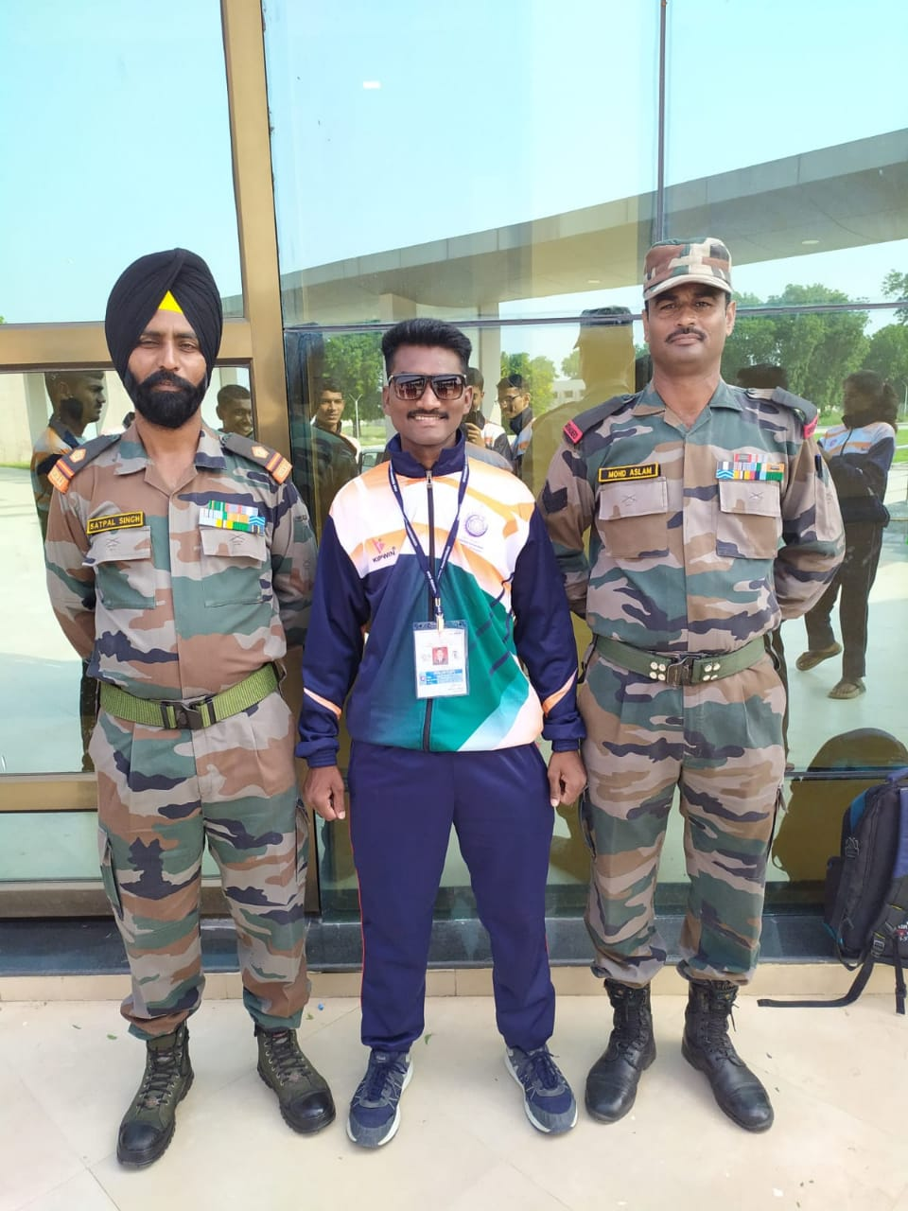
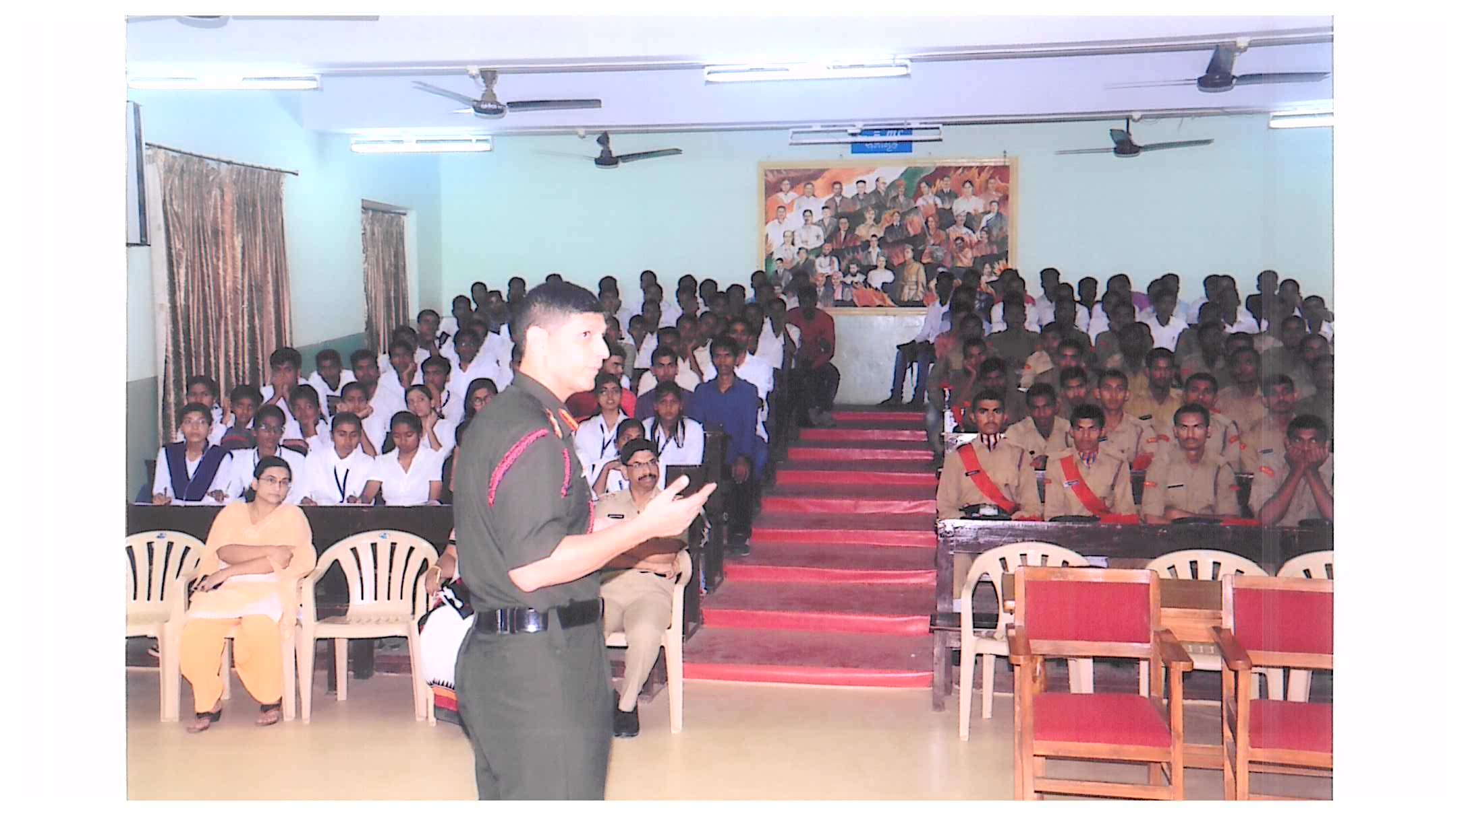
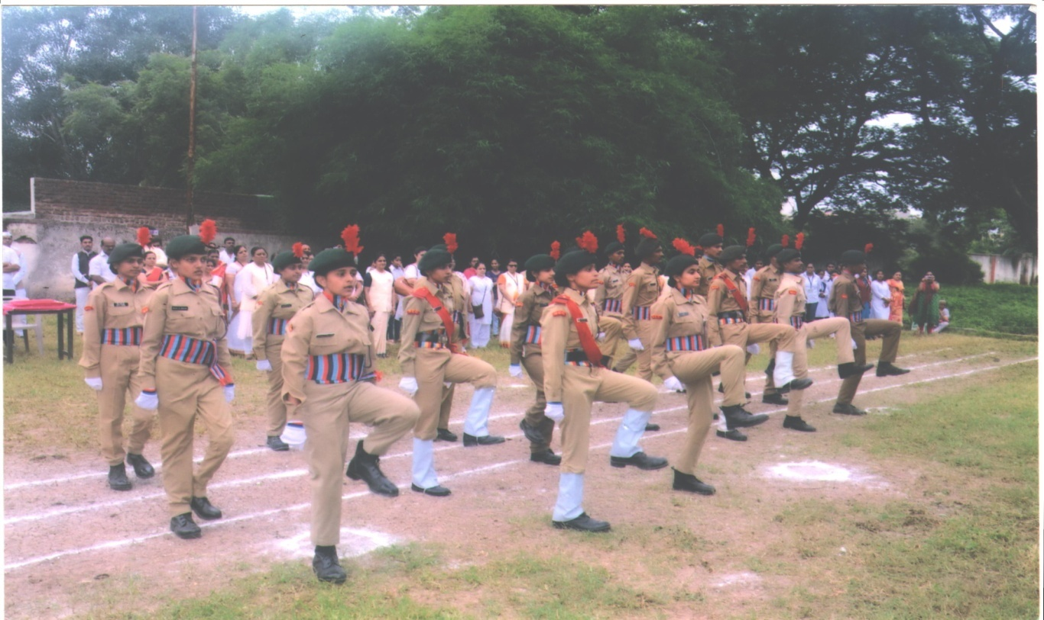

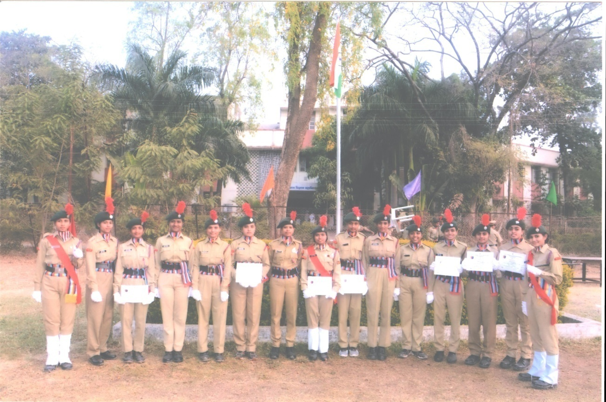

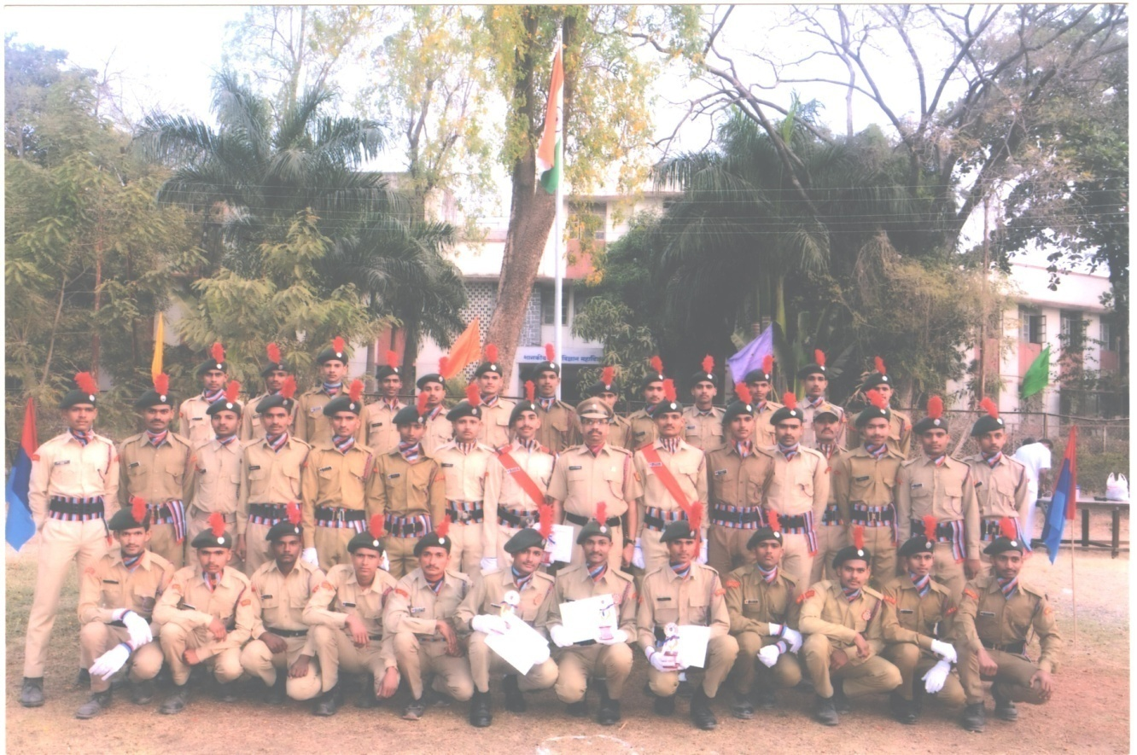

STATISTICS OLYMPIYAD
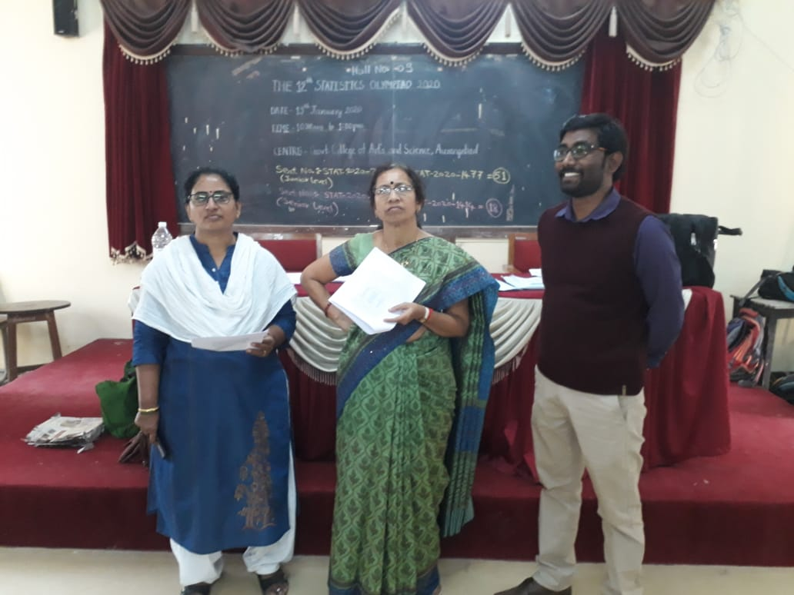
PARENTS-TEACHER MEET

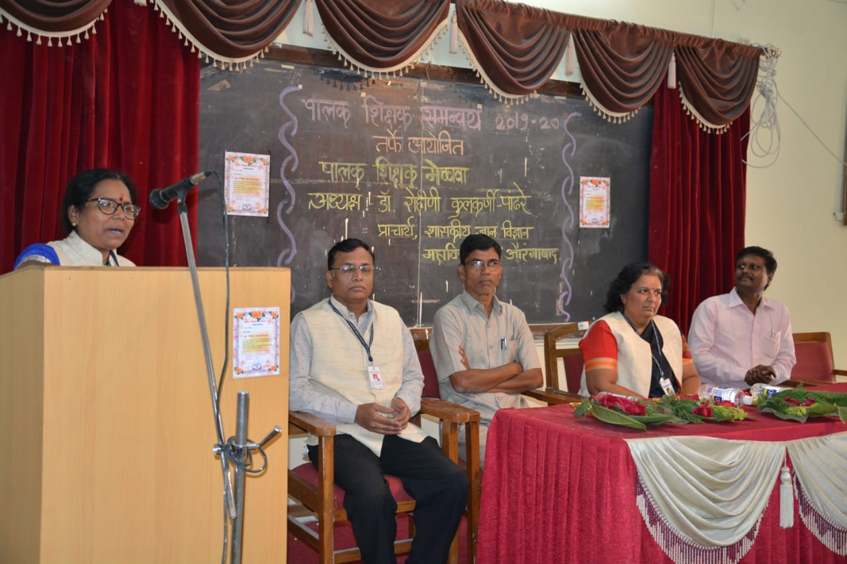

PRESENTATION BY STUDENTS ON THE OCCASSION OF HINDI-DIWAS
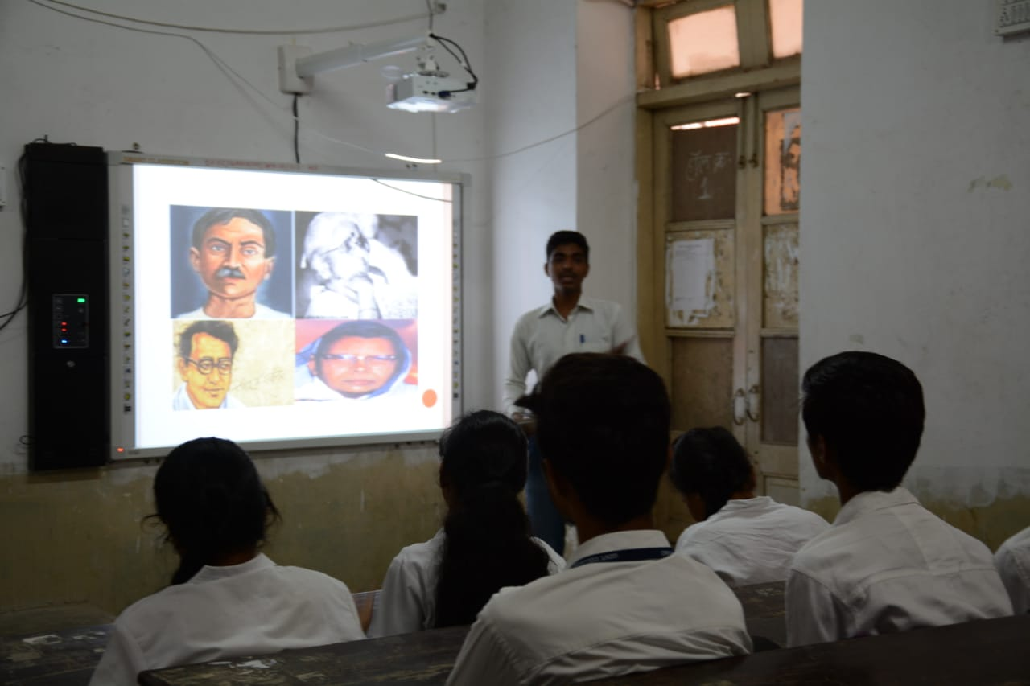
CONTINUOUS 5 HOURS READING ACTIVITY BY STUDENTS 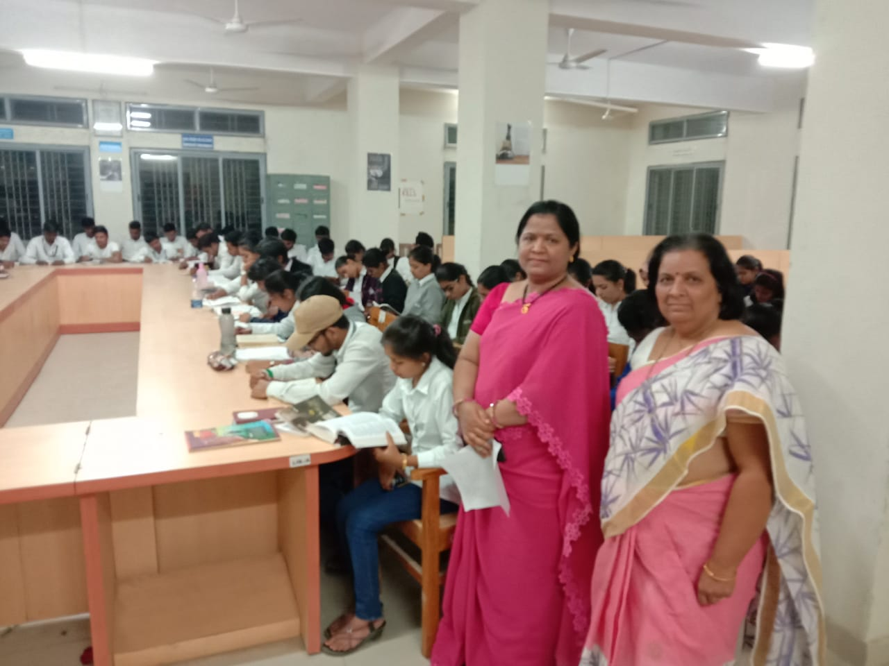

BOOK EXIHIBITION IN THE LIBRARY
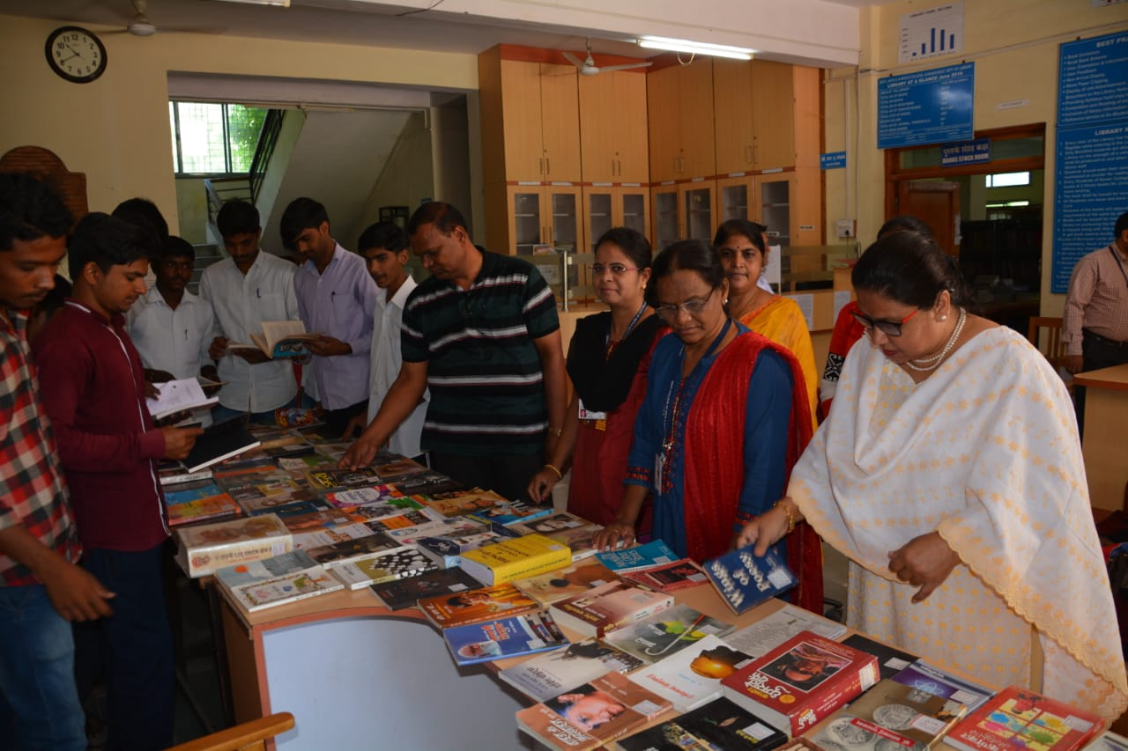

SUCCESS
KUMAR MANGAL KALIA UNIVERSITY TOPPER
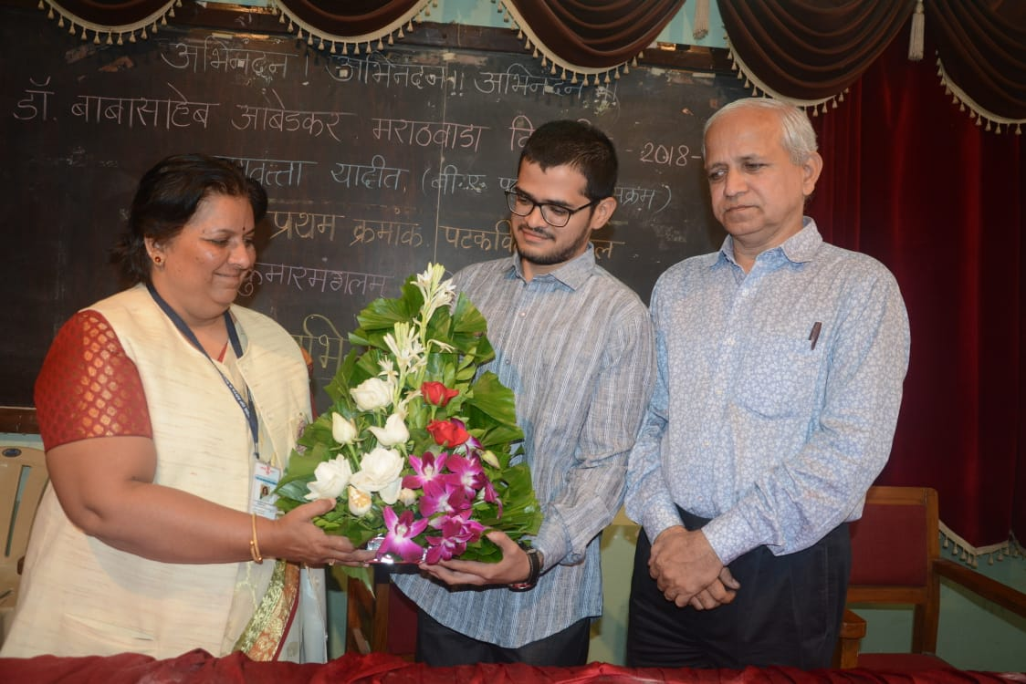OUR MERITORIOUS STUDENTS

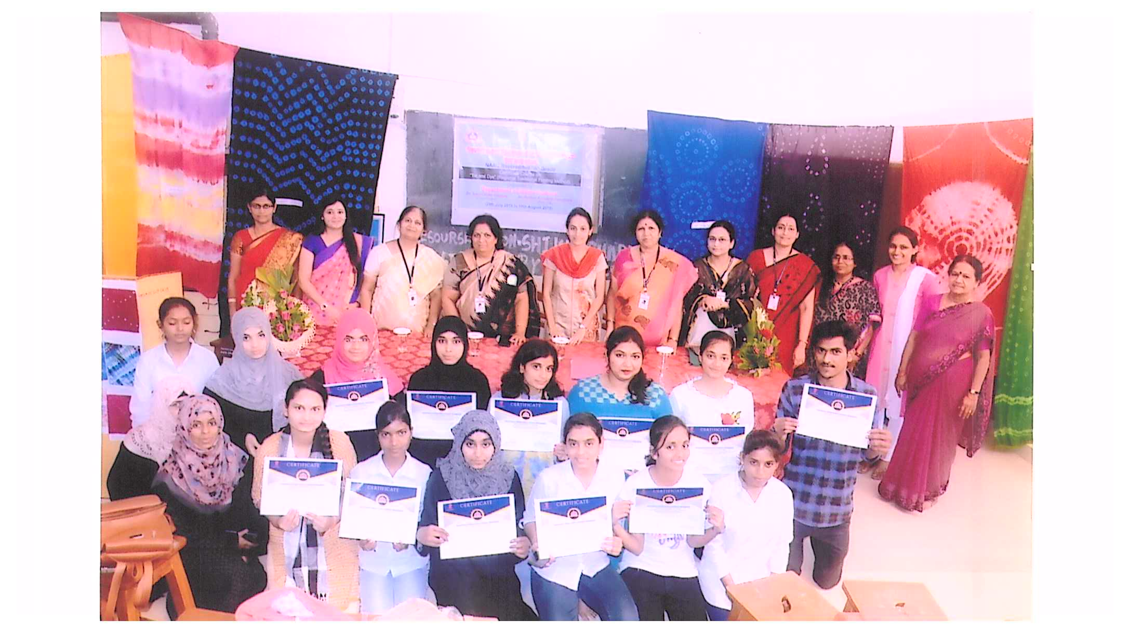

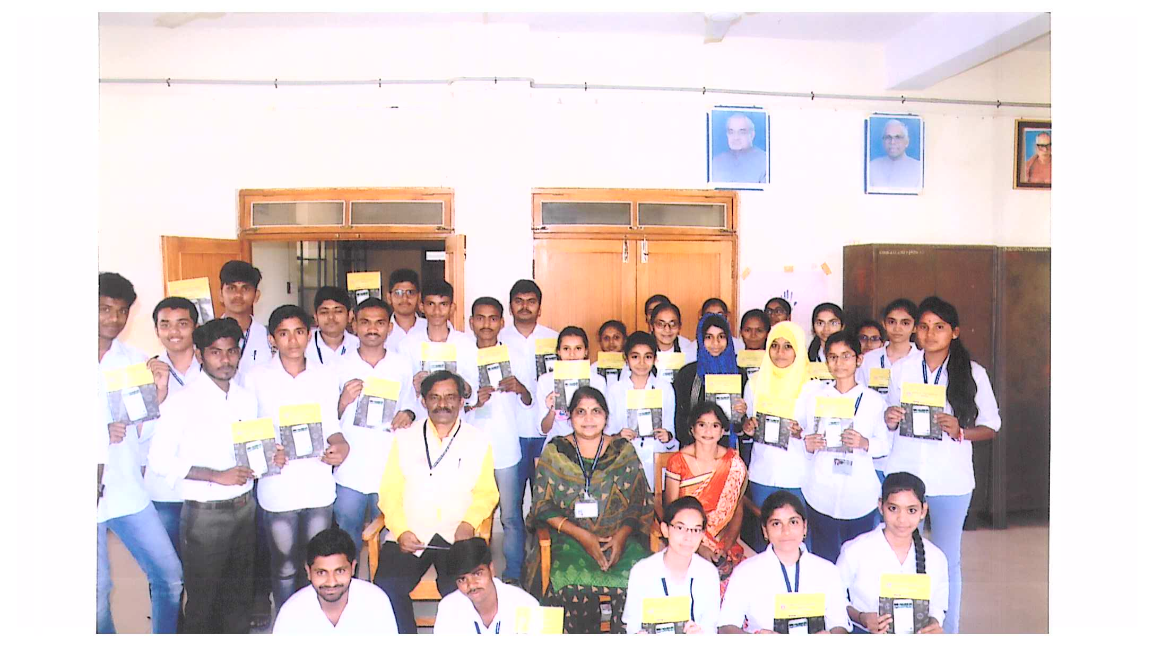
SPORTS WINNER
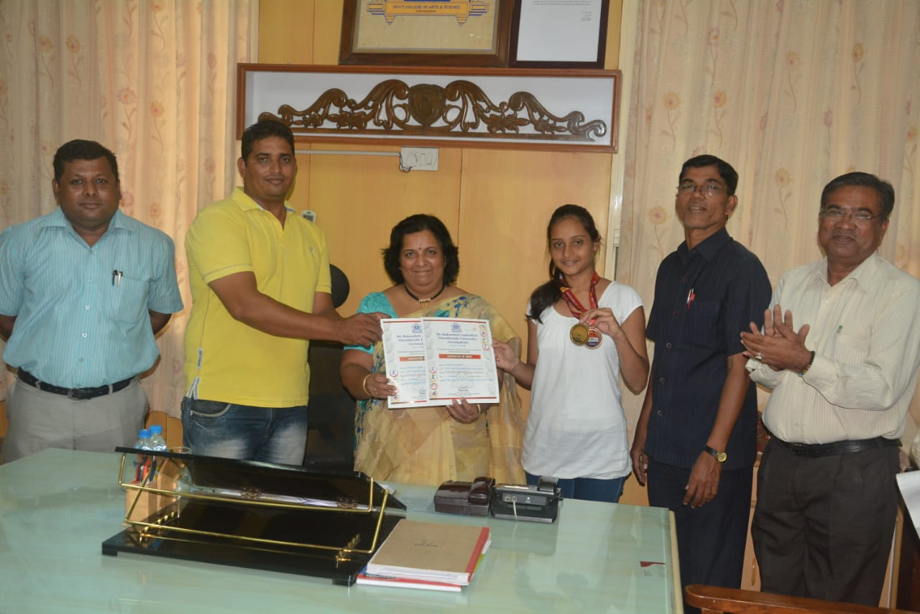
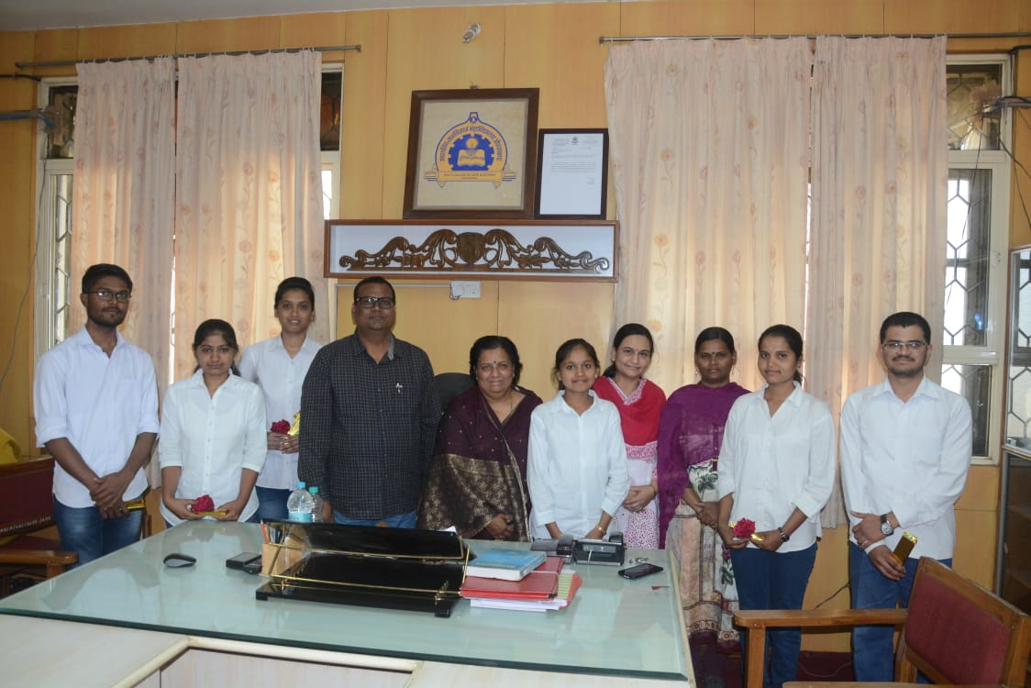

PARTICIPATION OF STUDENTS IN ACTIVITY ORGANIZED BY MAHARASHTRA TIMES

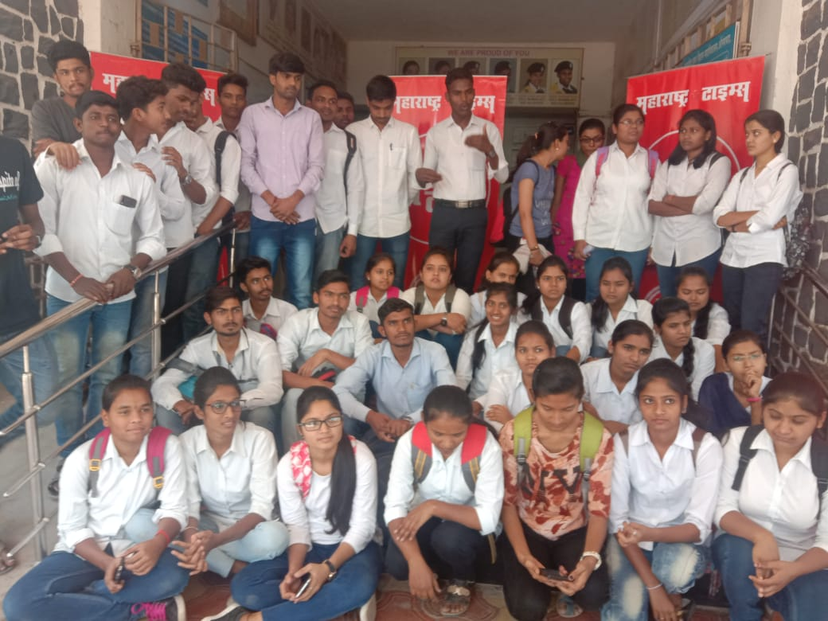

MODEL AND CHART COMPETITION BY ZOOLOGY DEPARTMENT
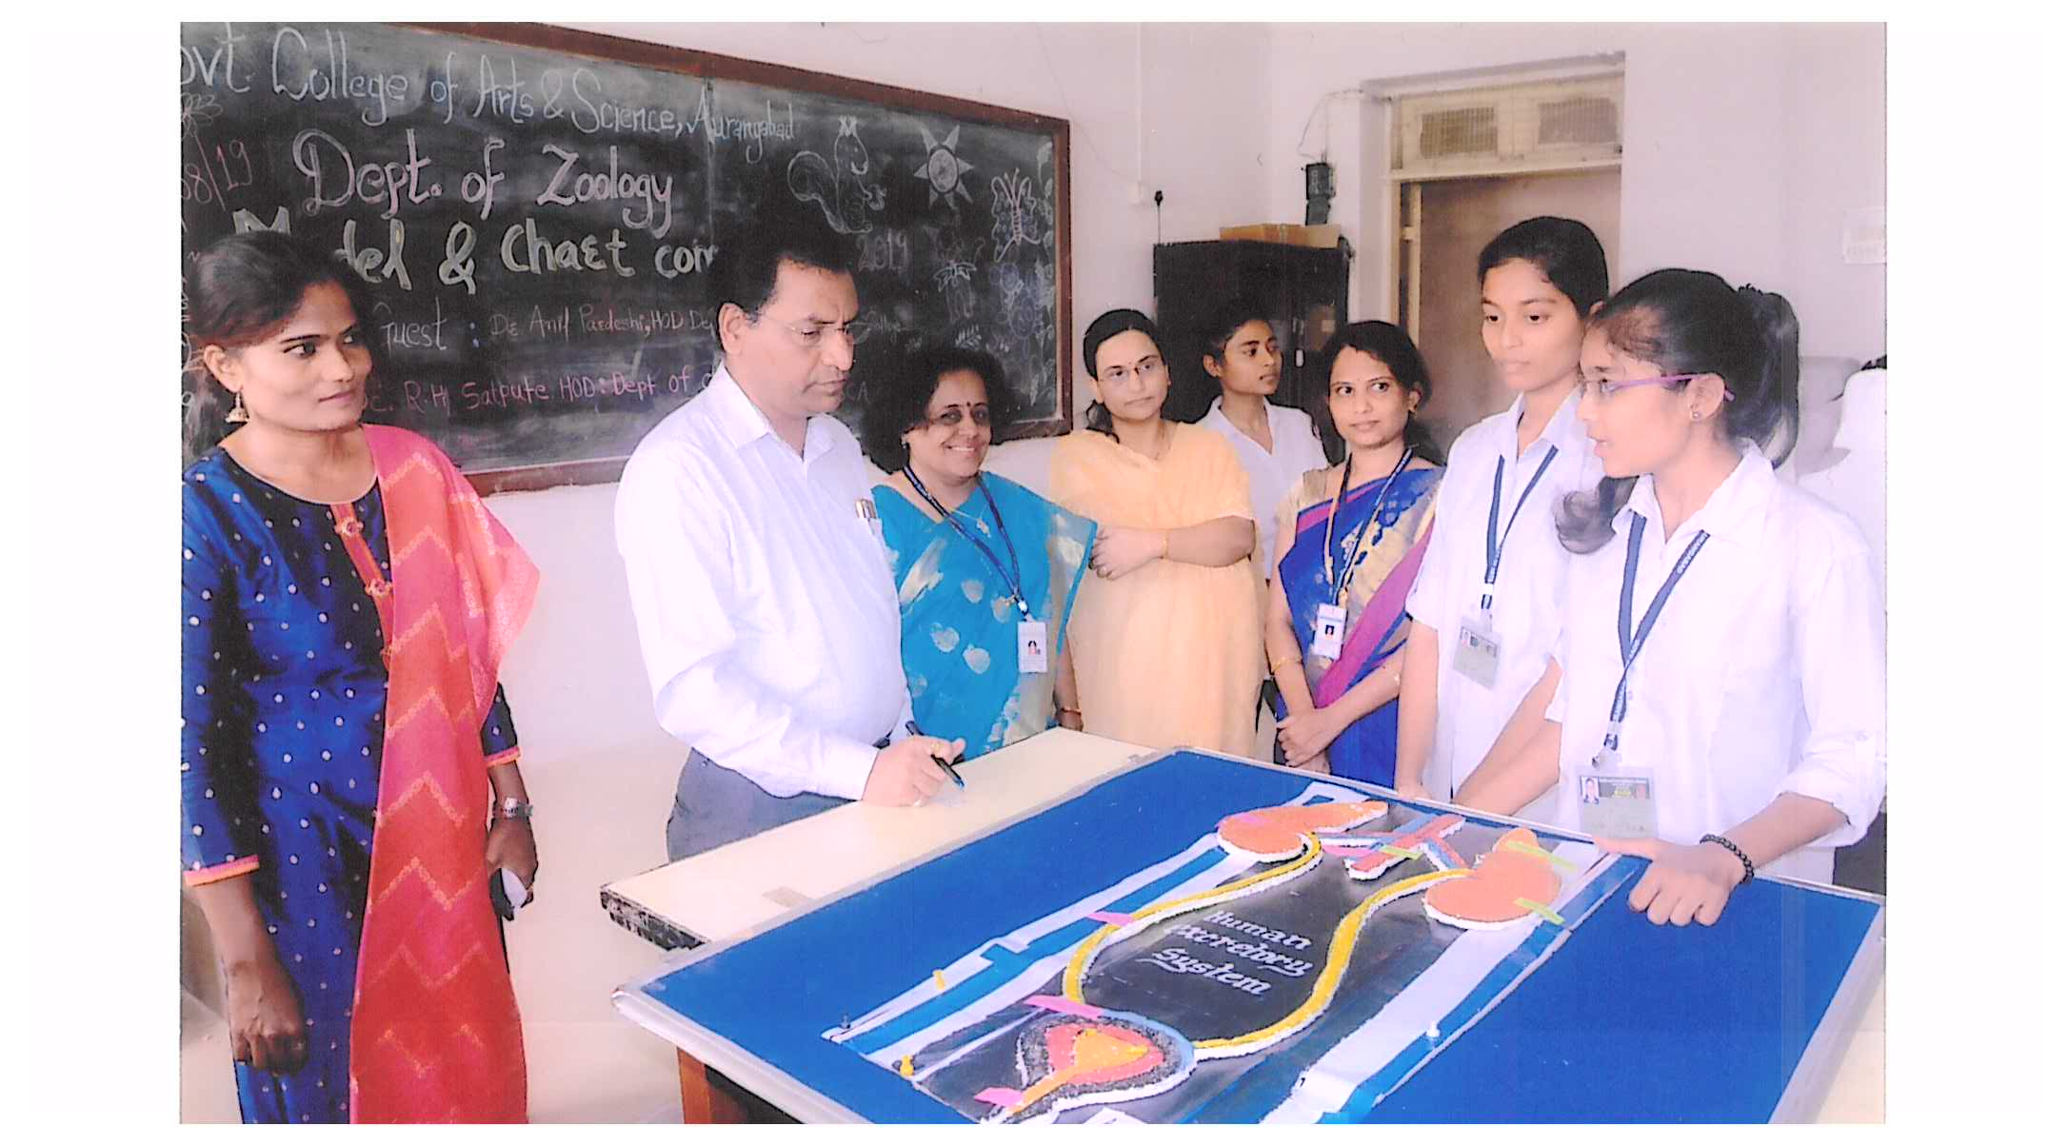
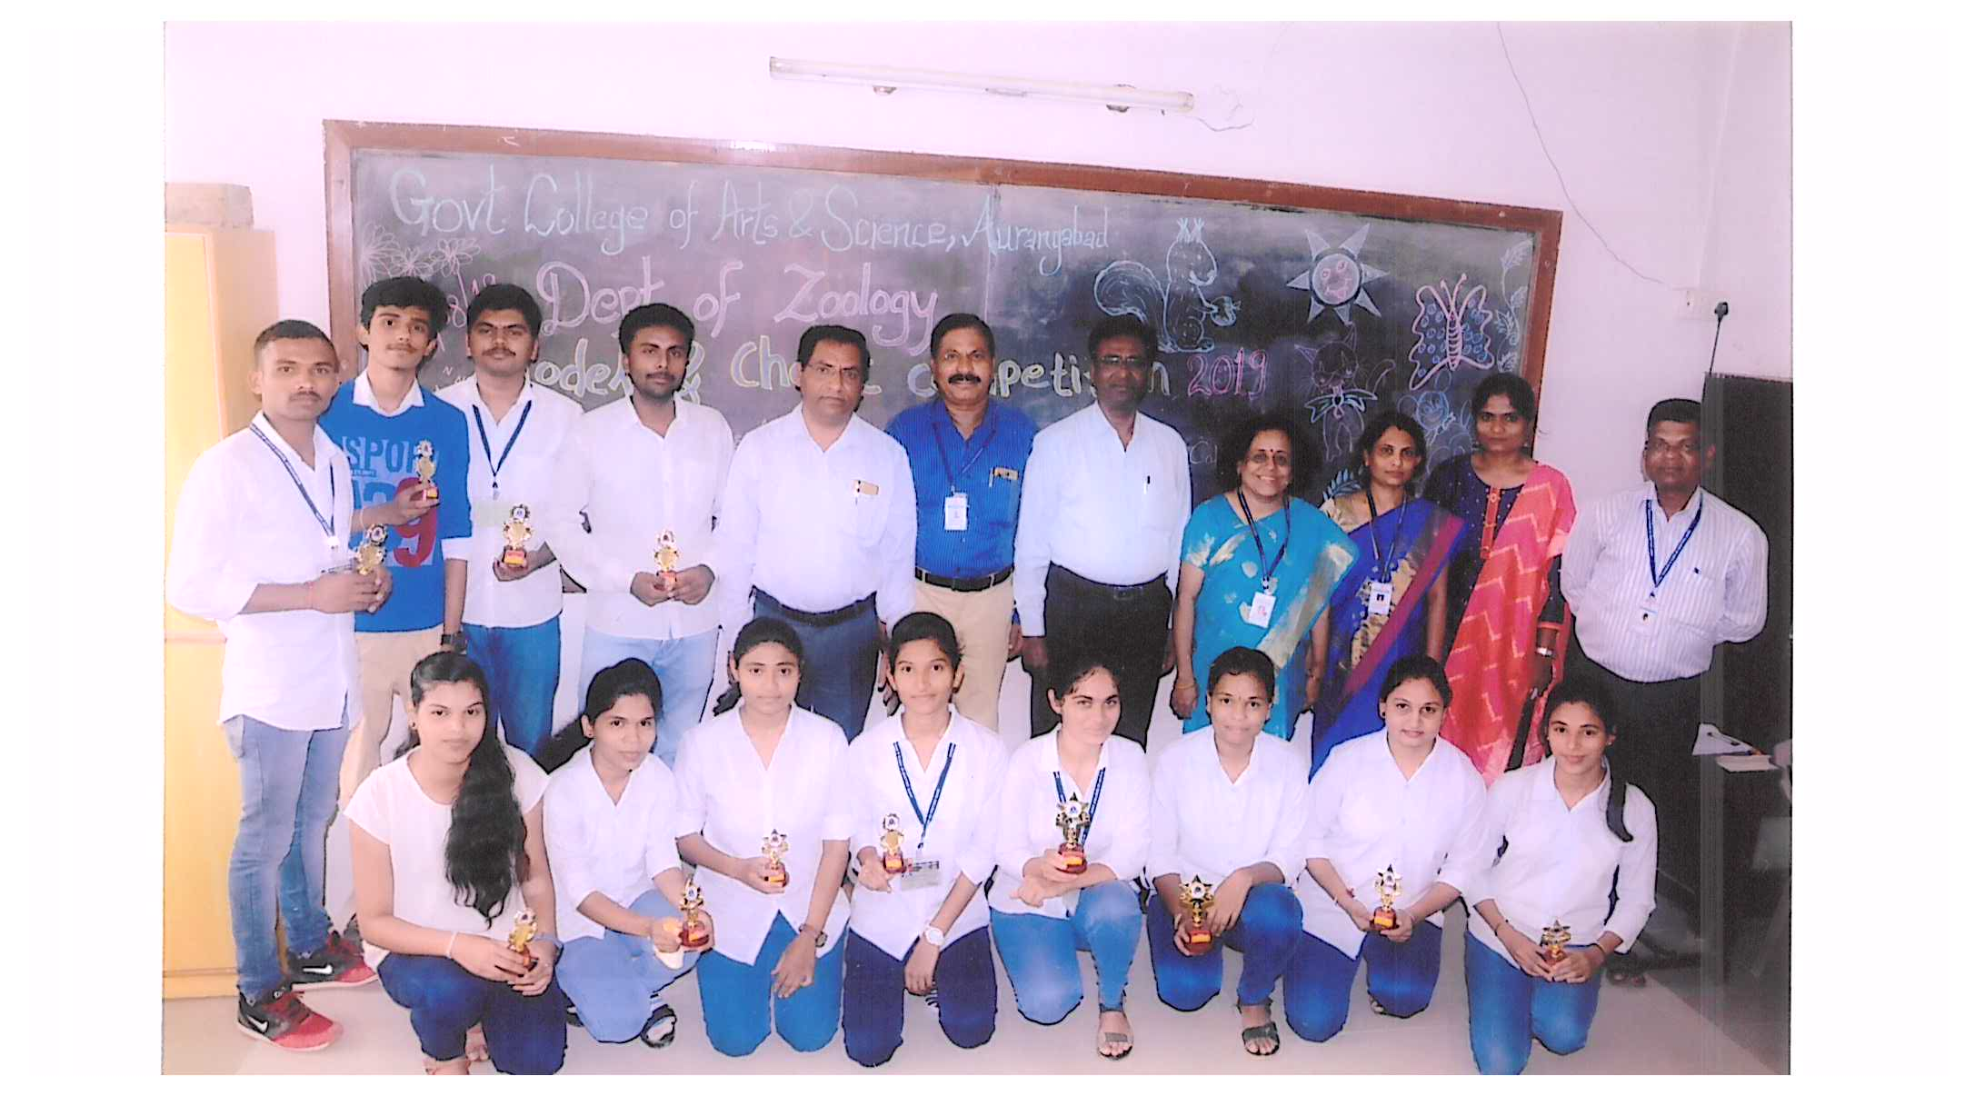
CHART COMPETITION BY HOME SCIENCE DEPARTMENT
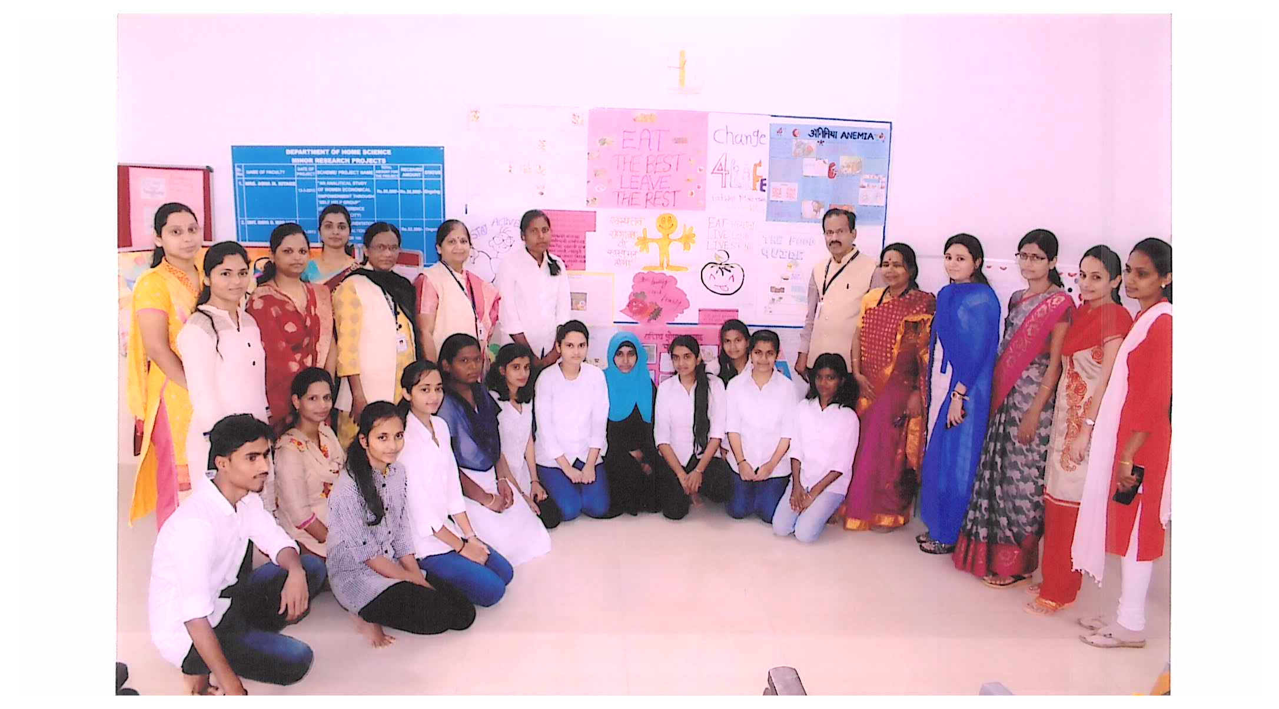

CHART COMPETITION BY SPORTS DEPARTMENTS

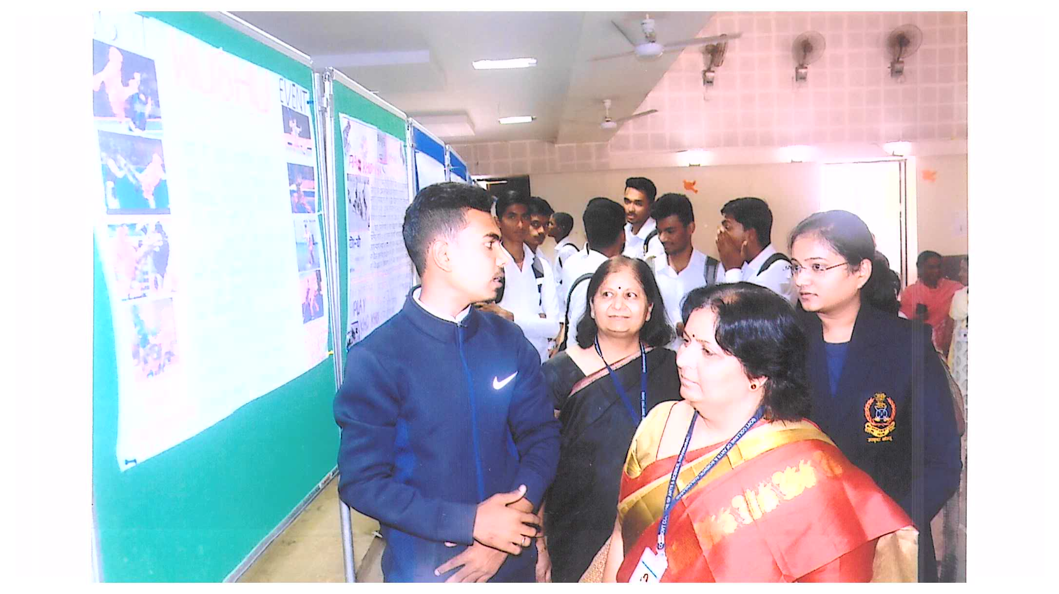
COMPETITIVE EXAM GUIDANCE
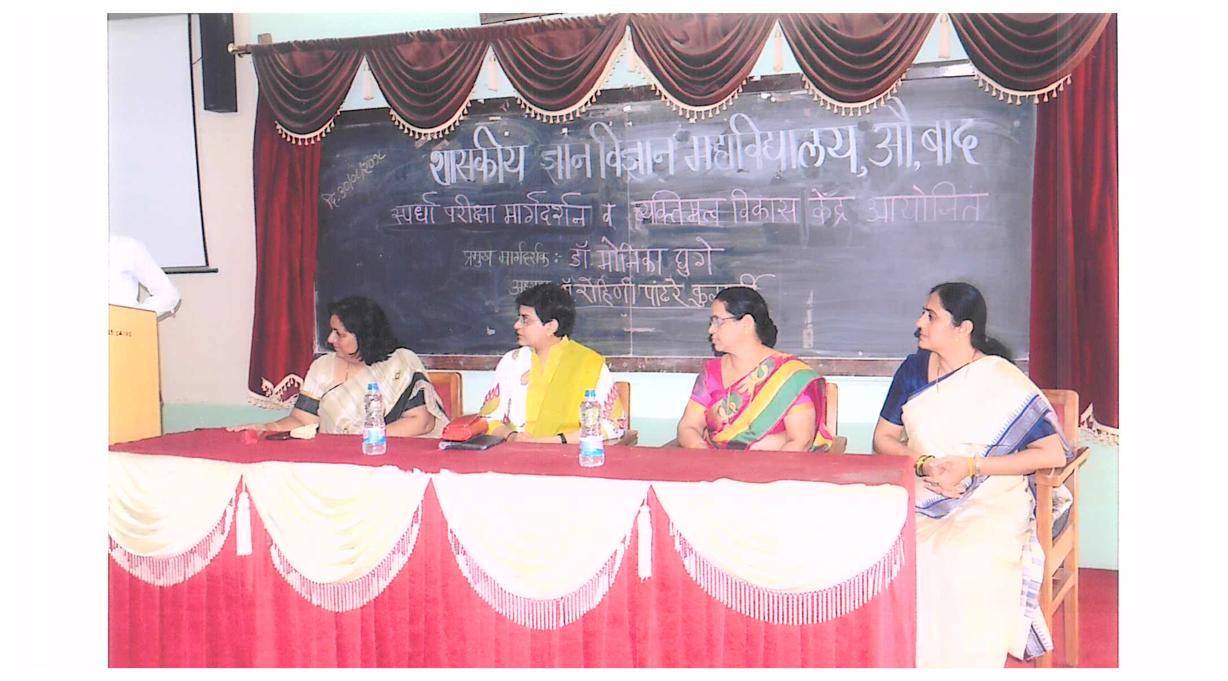
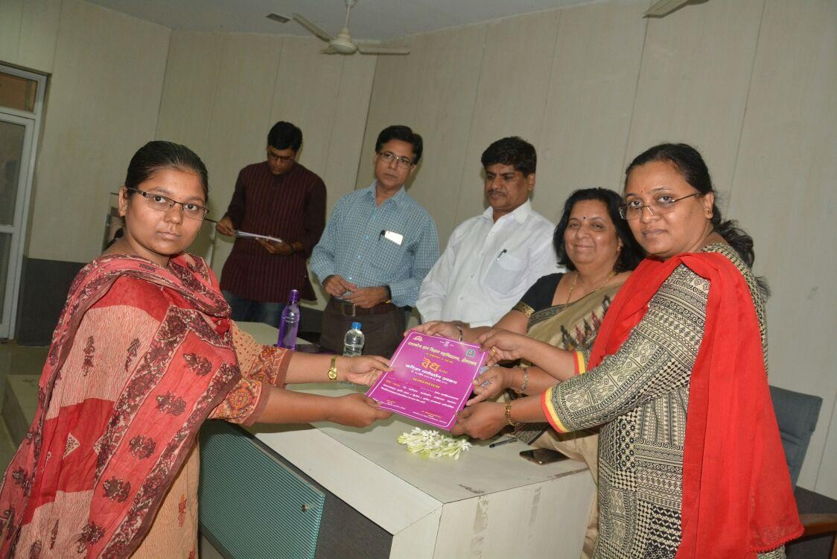
VEDH 2018 CONCLUDING SESSION

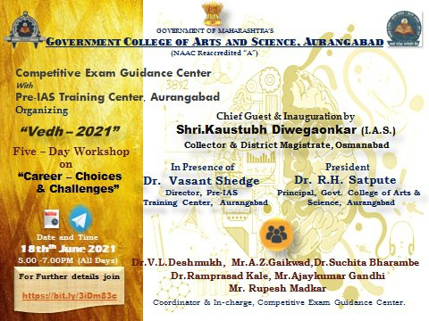
MENTAL AND SPIRITUAL TRAINING

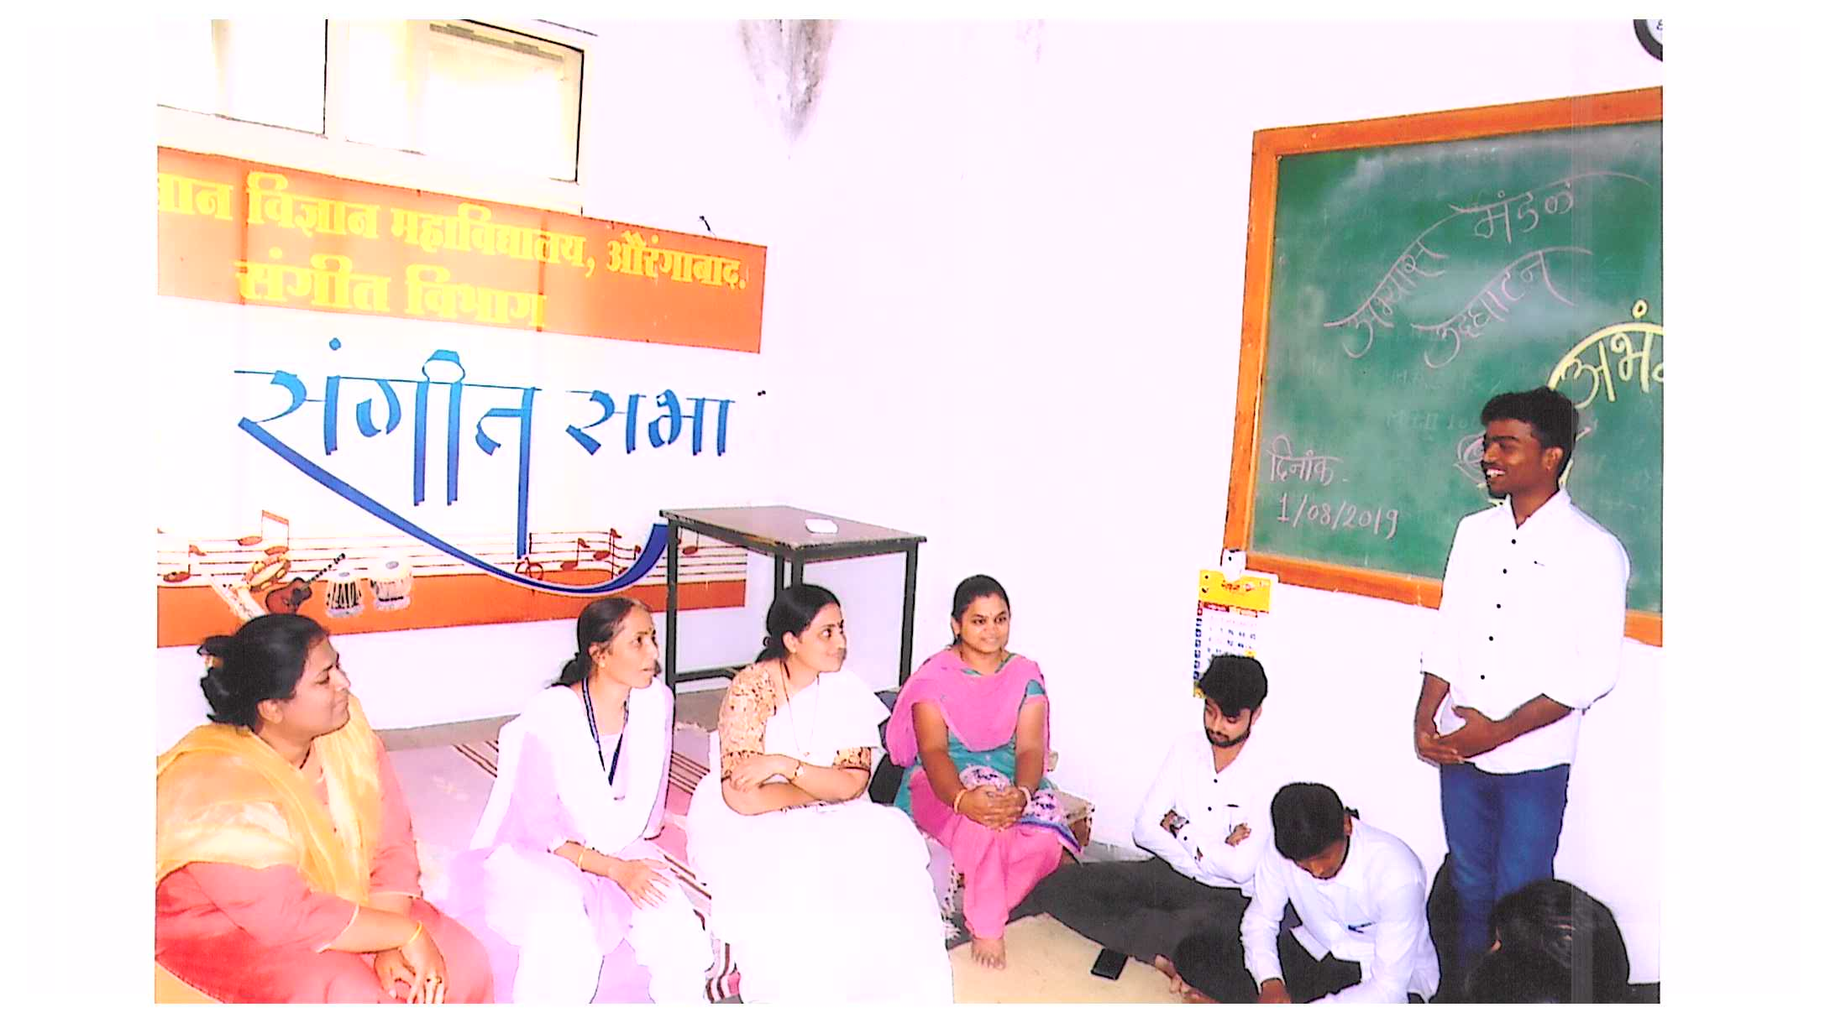

VACHANKATTA
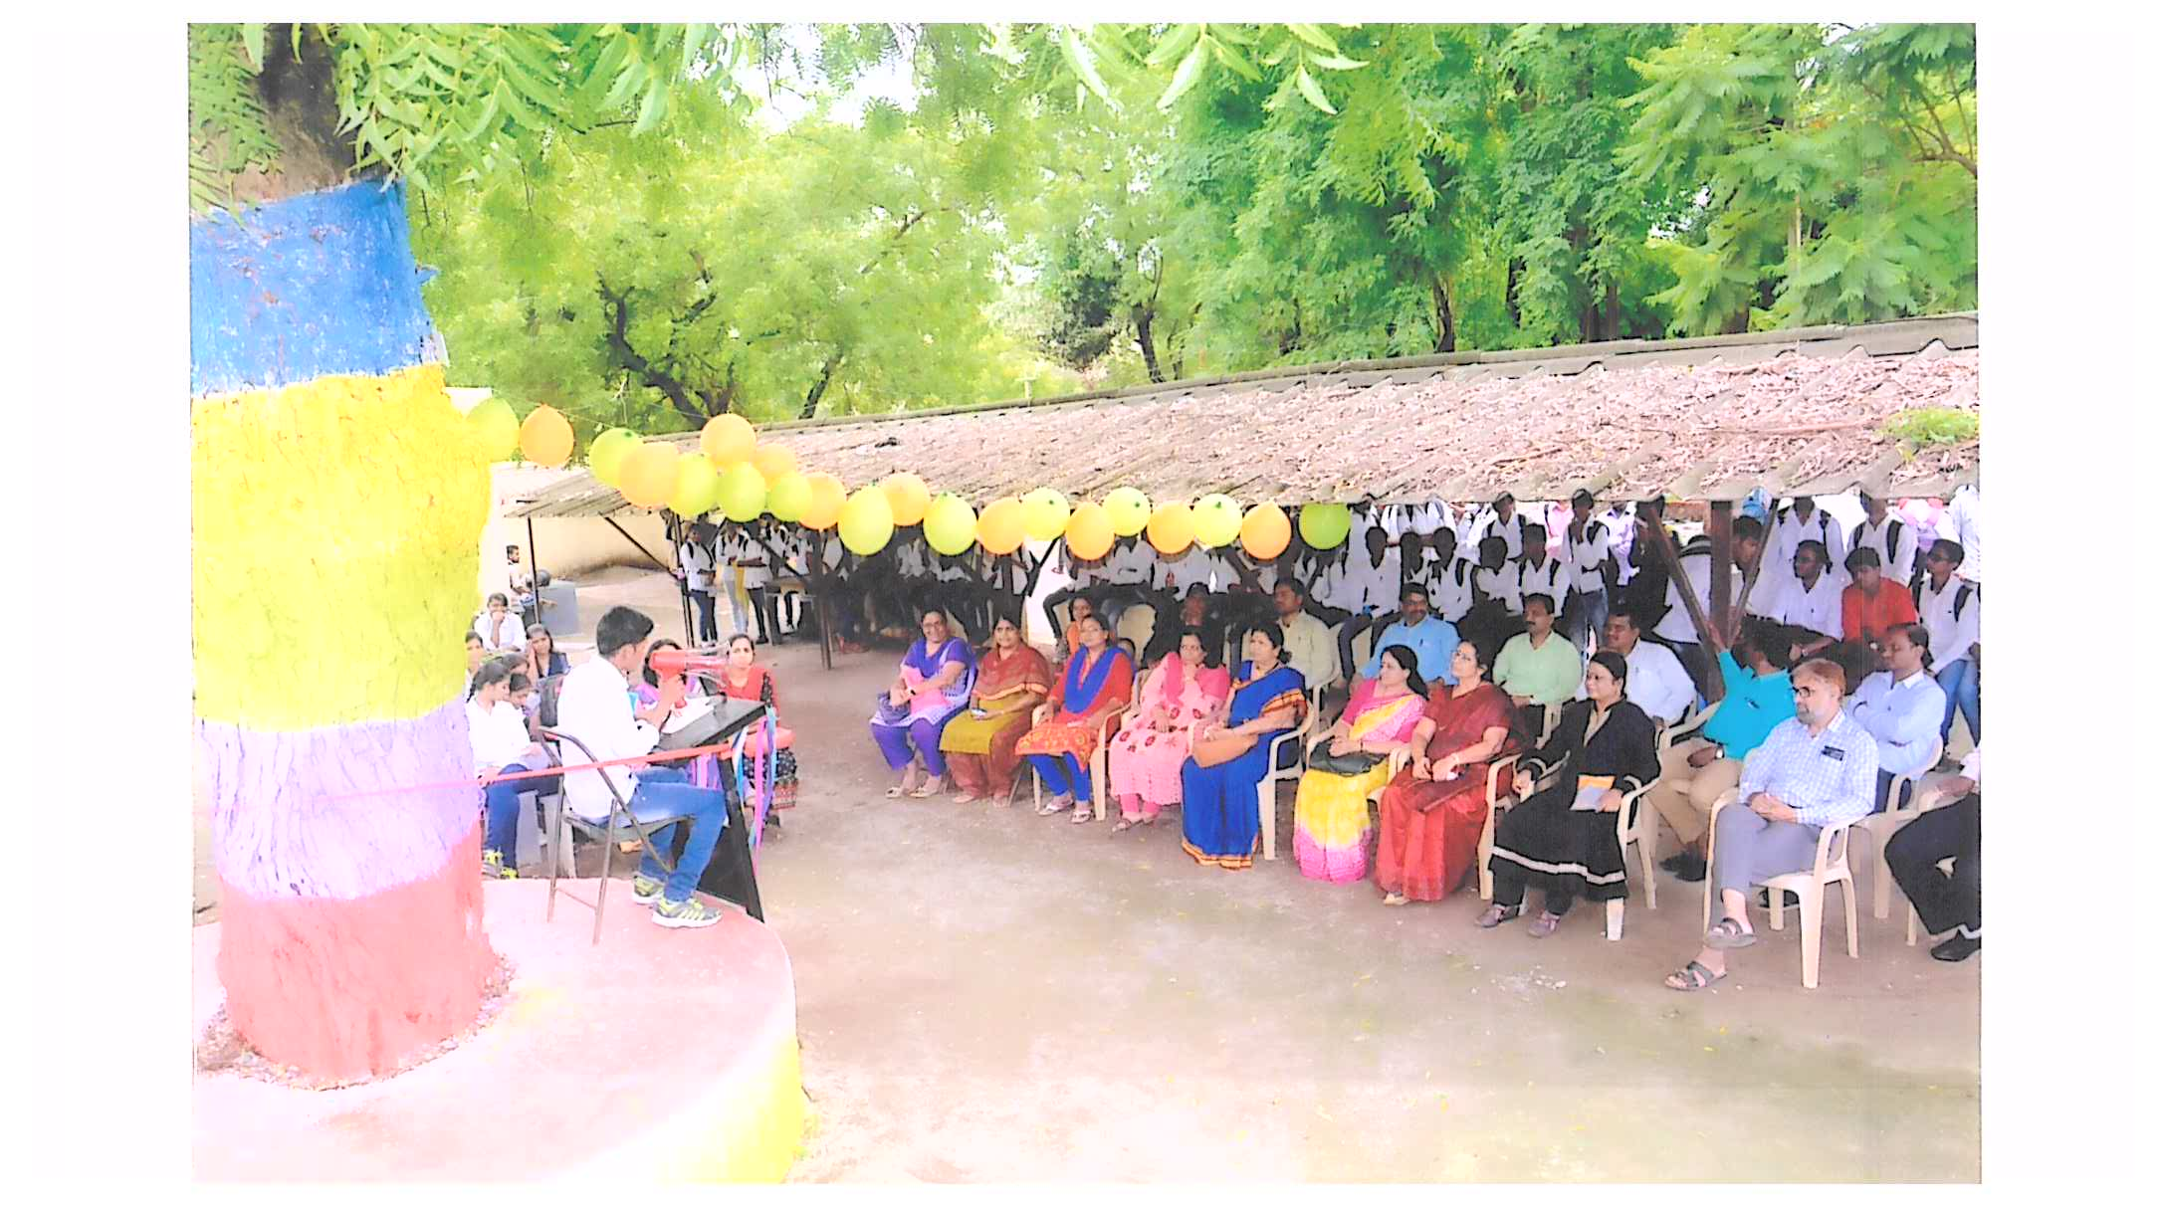
DEVELOPMENT OF RESEARCH
ACTIVITIES BY SOCIOLOGY DEPARTMENT

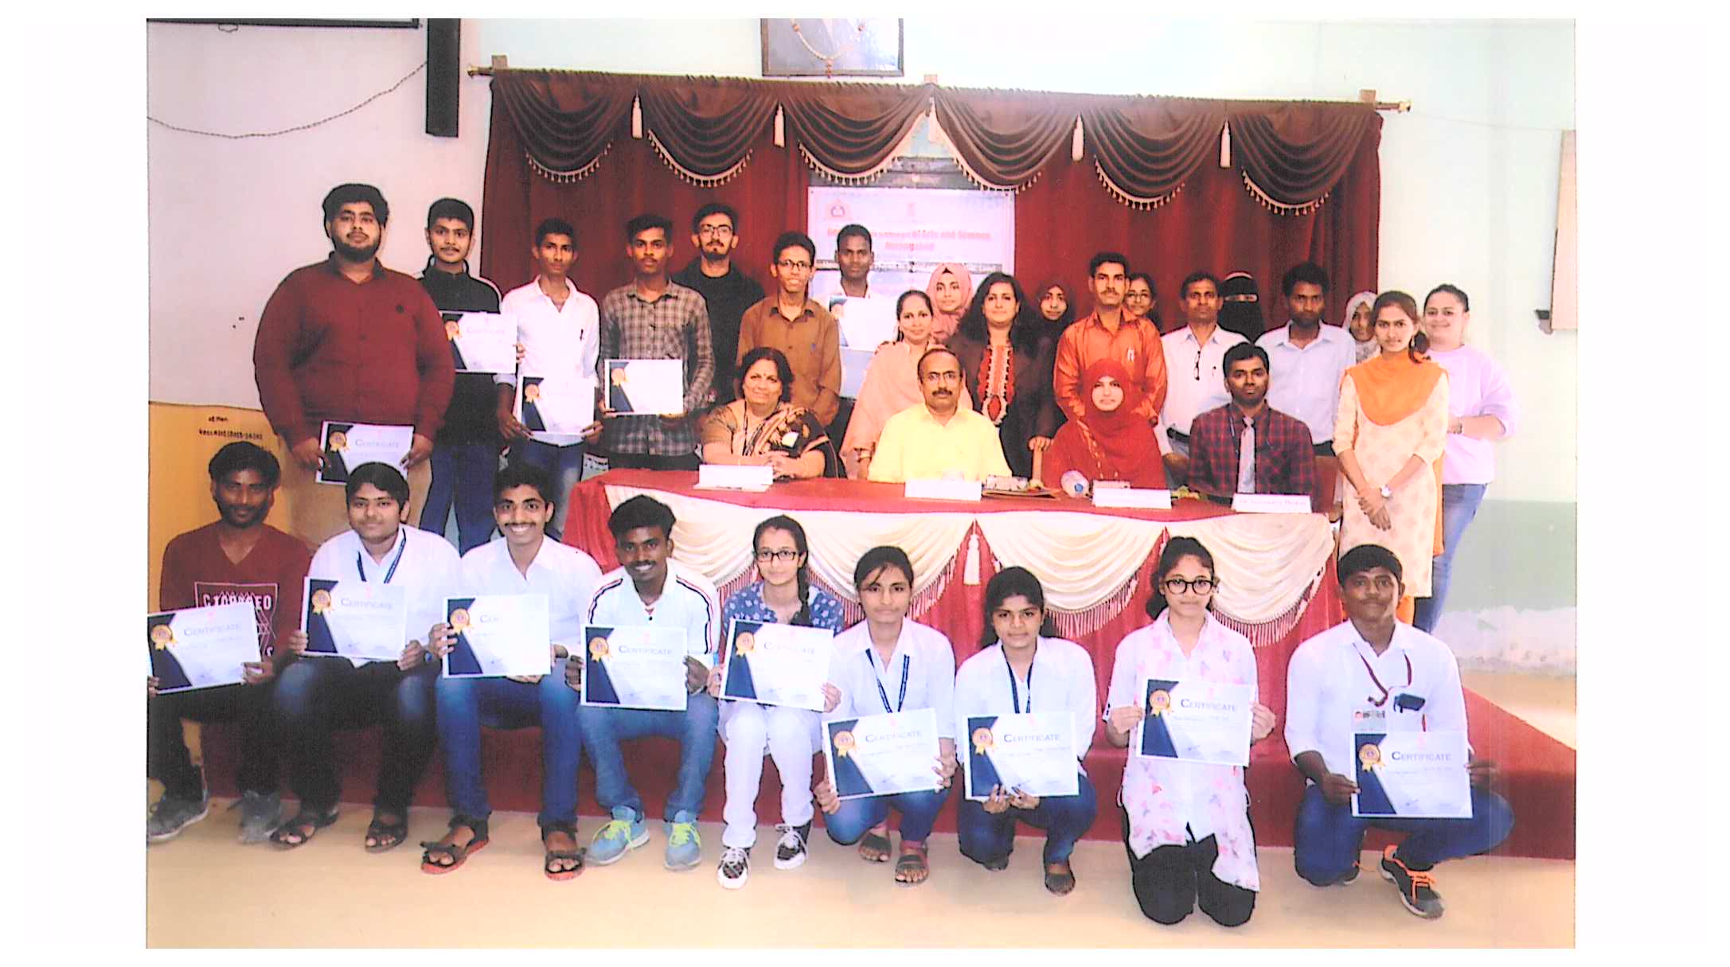
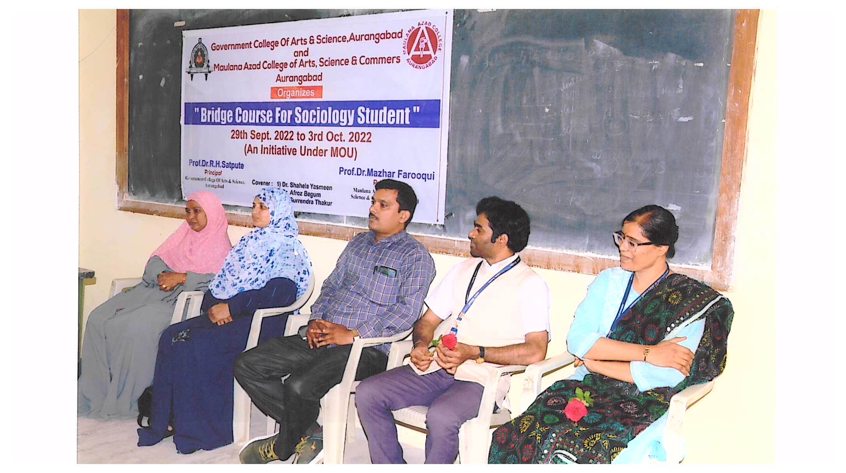
SANSKRIT AWARENESS RALLY BY NSS UNIT

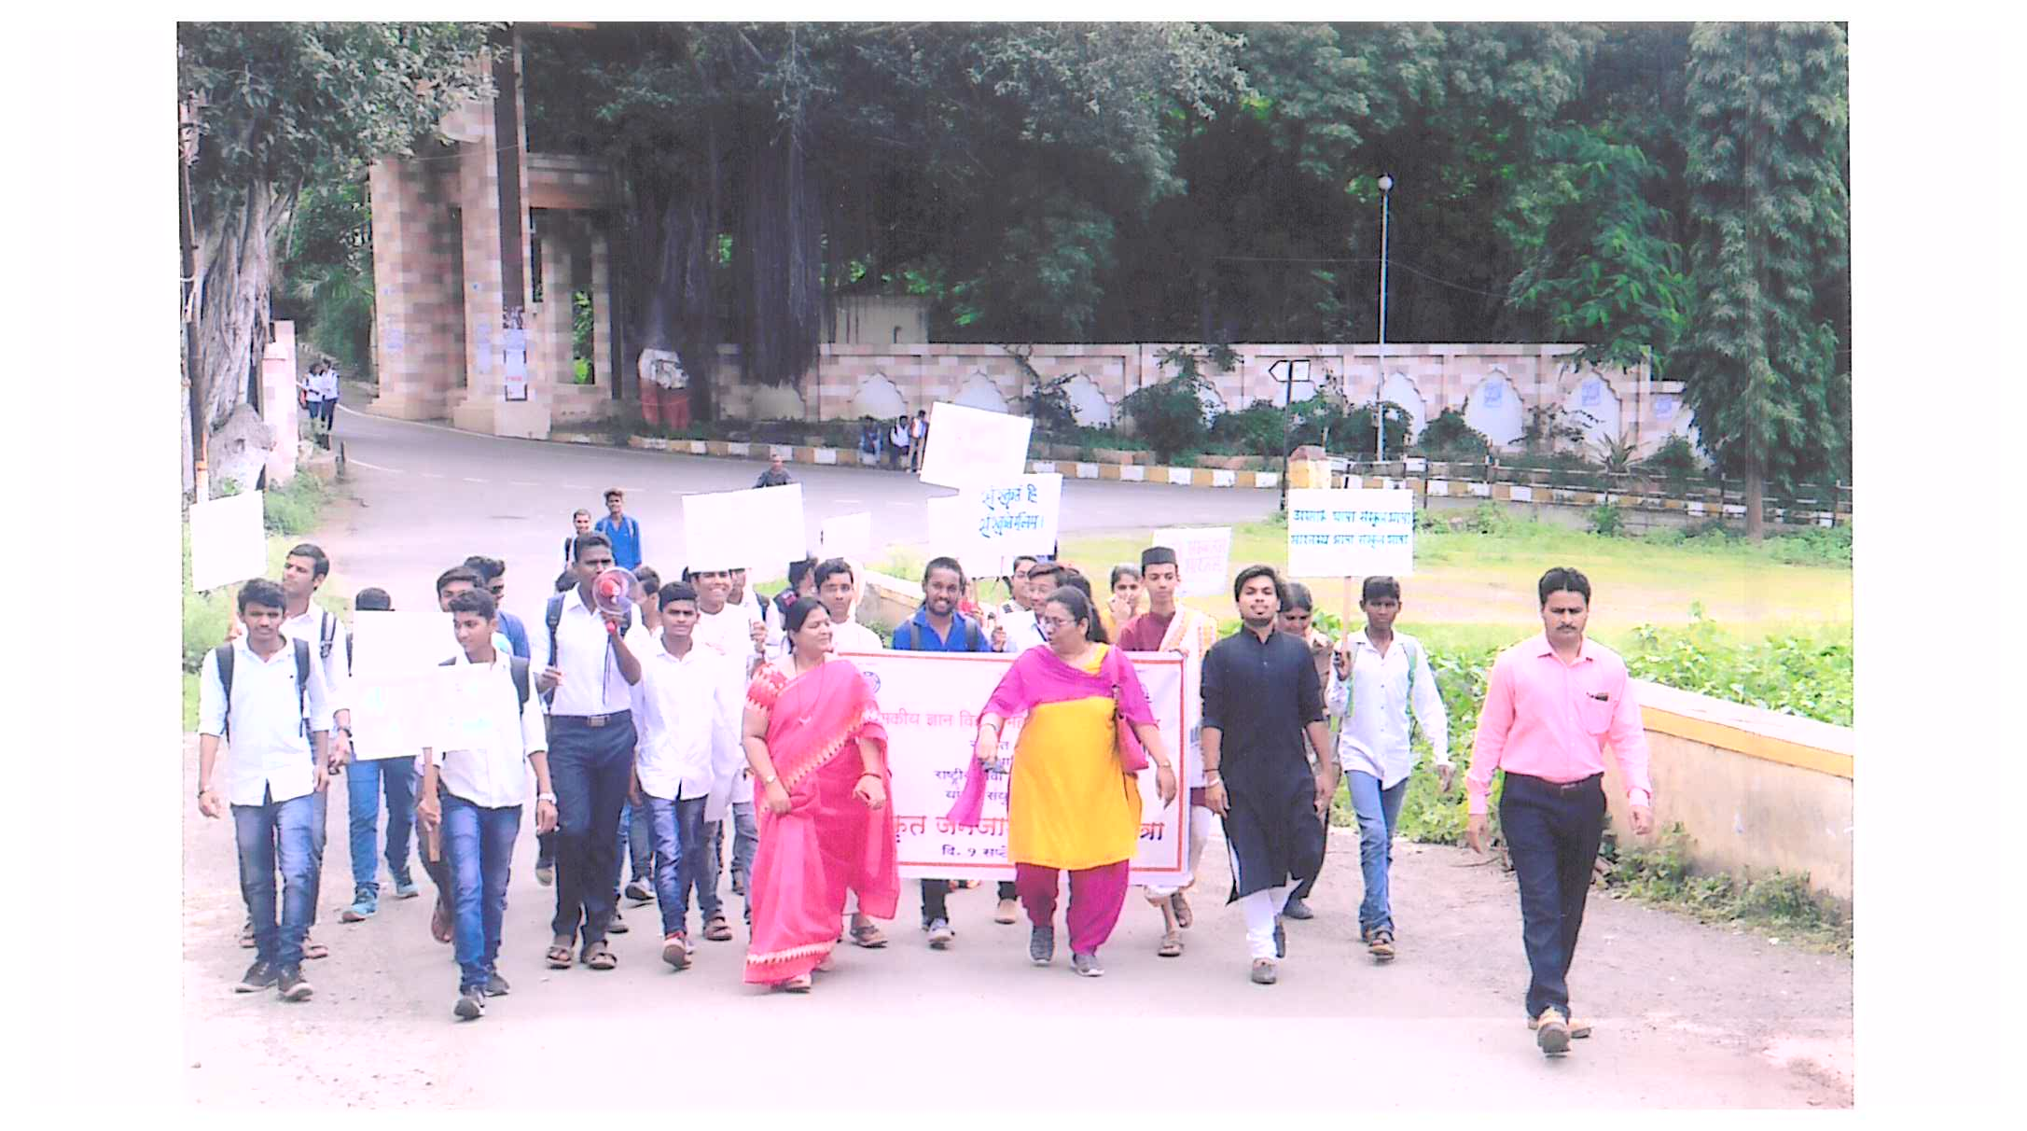

VALUE EDUCATION
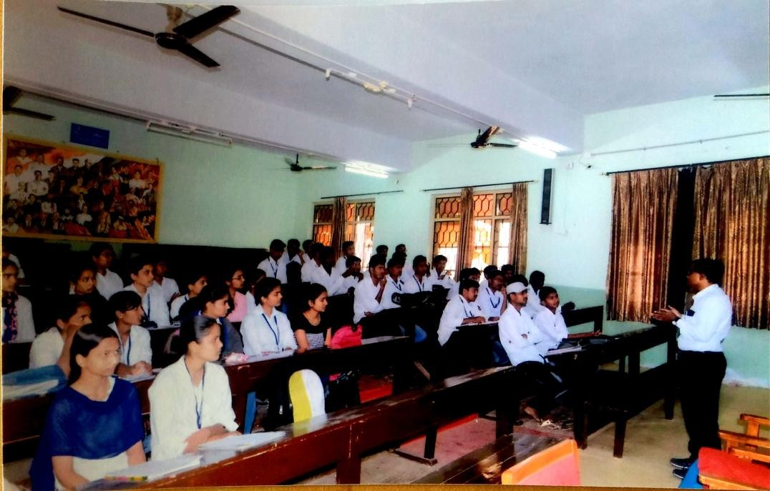

2.Dr.AnandNikalje,Speakingabout how to understandmovies.
HowtoWatch/UnderstandMoviesWorkshop

NEWS OF VARIOUS ACTIVITIES IN COLLEGE
